Callem Lawrence English | 75 Dyas Avenue ,Great Barr, Birmingham, B421HQ  Callem_1990@hotmail.co.uk, 07946822646 www.linkedin.com/in/callem-english-6608b4a3
CNC Router and Miller Setter/Operator |CAD/CAM Design Engineer| Warehouse Operative Profile

An analytical and results-driven individual with hands-on experience managing Computer Numeric Controlled (CNC) equipment from setup to operation, producing parts and tools from different resources including wood based fiber and cement fiber. Skilled in creating quality products specific to engineering drawings and client standards. A keen focus on developing, modifying, and optimising CNC programs using Computer-Aided Manufacturing (CAM).
- Instrumental in programming flatbed and pods cnc routers by entering instructions, 7setting tool registers, and calculating requirements, while ensuring quality assurance and control.
- Articulate communicator can understand the language of both people and technology, blending technical expertise with interpersonal skills while interacting with client/teams and providing product/client support.
- Experience in managing warehouse activities, including stock counting and location checks, packaging and delivery, preparing and completing warehouse orders, and operating forklift.
- Experienced in using CAD/CAM programs I have assigned tools, set toolpaths run simulations and optimized design programs such as Alphacam and Haas programs, where as I have worked with materials such as plastics, wood metal, chamfered and rounded edges of plastics, imported different macro’s when manufacturing Vernier doors and created aluminium extrusions.

AREA OF EXPERTISE

- C  - Q  - P | NC Machine Management uality Assurance roduct Development | - Cross-functional Communication  - Superior Customer Service  - Process/Procedural Adherence |  | •  •  • | Equipment Maintenance  Records Management  Inventory Management
 | PROFESSIONAL EXPERIENCE

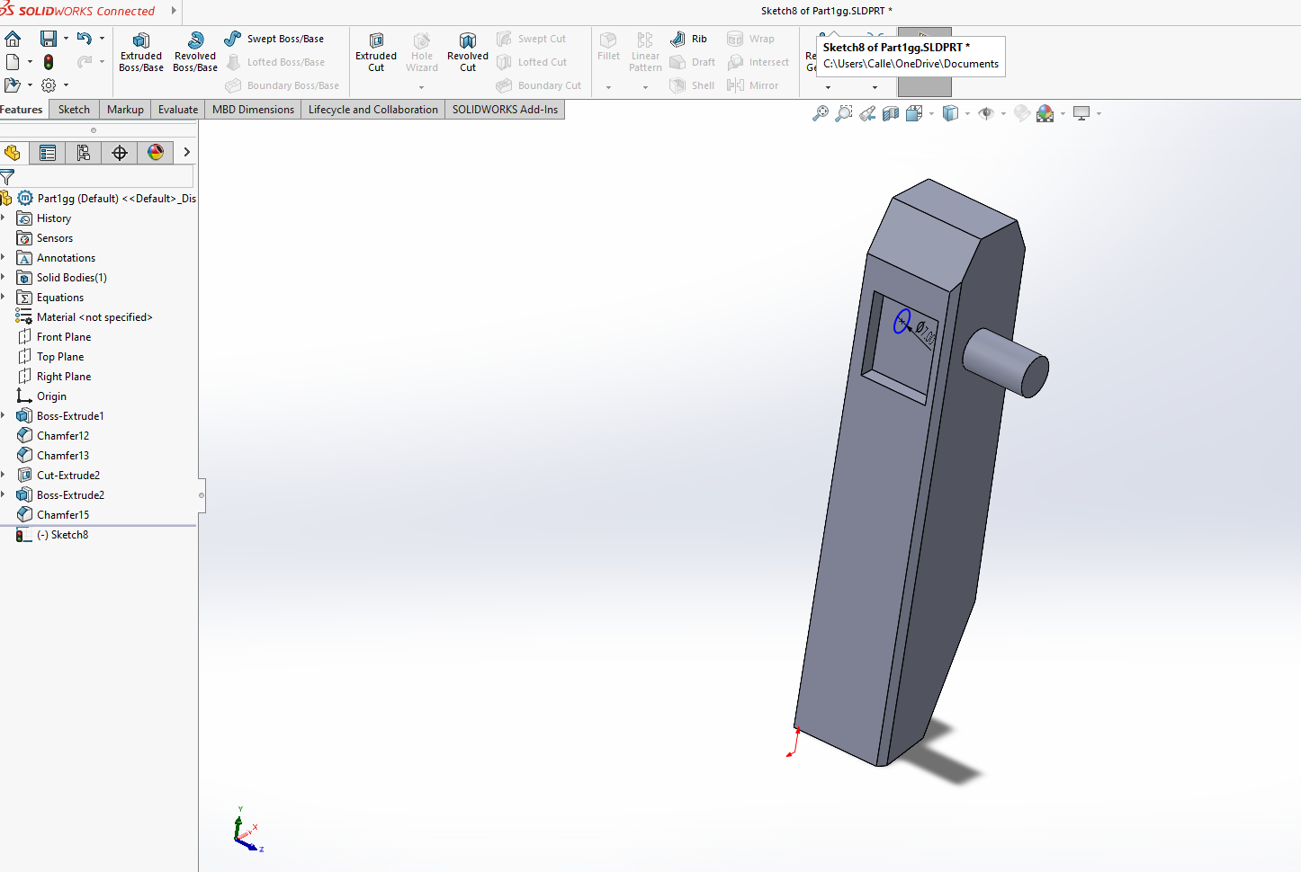
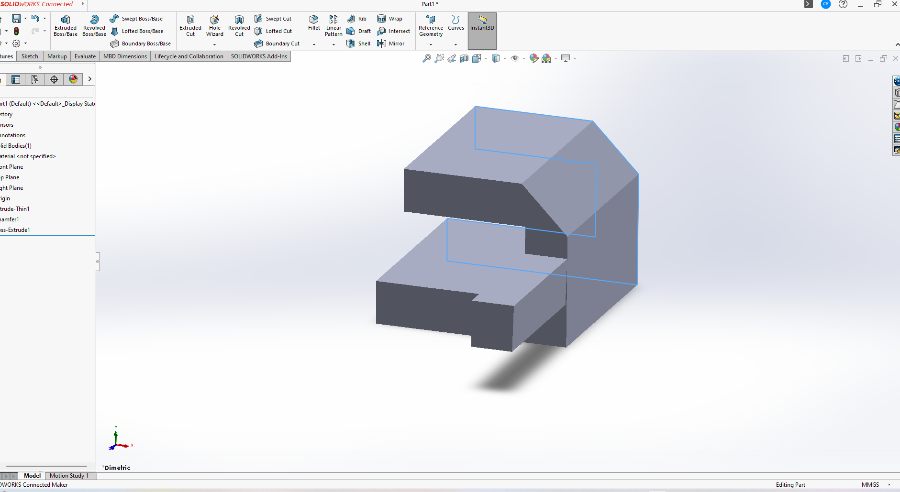

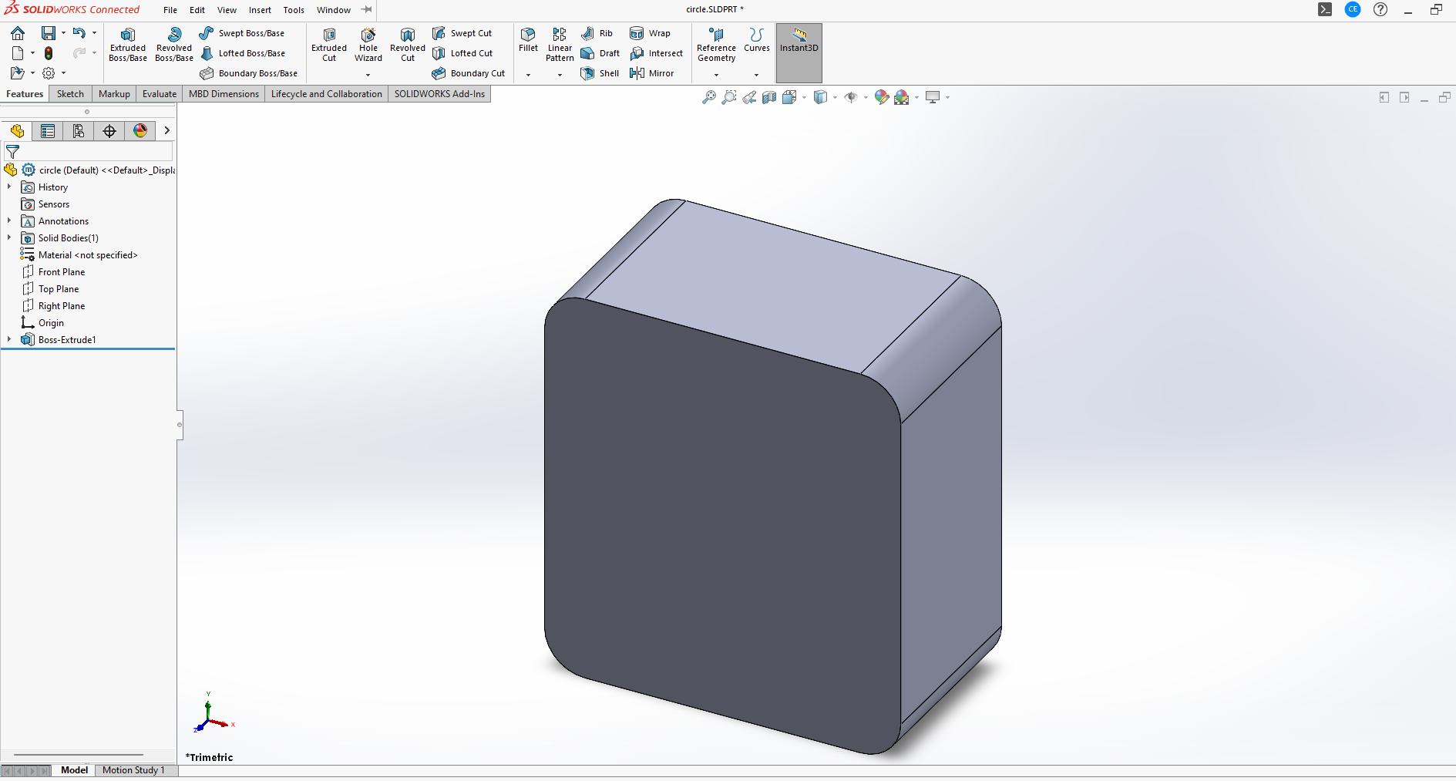

Please see screenshots of sketches produced by myself on SolidWorks being a CNC Operator/ Setting for over 12 years, I am in hope of that big breakthrough becoming an design engineer starting as a design trainee working my way up, to a dedicated experienced one, I work very hard at home designing drawings as you can see from above some of my projects produced, given the chance to show my skills and ability, I will be the best employee you have ever employed.

Wolverhampton University
Wulfruna Street
B6 7AT FROM SEPTEMBER 2021 TO APRIL 2024

I have finished completed studying computer science at Wolverhampton University, in my first year the topics studied were introduction to programming some of the tasks involved being using python software, creating a hangman game which the user has to guess a word running in a while loop variable they only have 10 go’s to guess the correct answer the computer would pick a word at random choice for the user to guess.

I have worked with binary numbers using logism creating a large circuit adding sub circuits, broke down data into bite sized bits you may use an and gate or a nand gate or a or gate which you what add a switch and a input value for the computer to read off forming the circuit. Gates relate to truth tables. In my Third year i created Android games in java setting different references such as SavedInstanceState that is passed into an onCreate method having the ability to restore back to previous states, using the data already gathered in the bundle, implementing getters and setters,
Setting toast notifications that pop up appear on my android screen displaying information.

I have used Microsoft word and excel a lot creating reports for my software client prototypes basically a server client server that retrieves data from the openweatherdata website, the server having the capabilities of illustrating that information on to a website so say for example if a user wanted to know what the humidity is like in London for they’d have easy access finding that out by simply copying my html api link of my PhP copying it on to the internet which the info would be displayed, I mainly used word to write reports the pros and cons of my server.

I have used Tinkercad an app for 3d design and coding to create circuit diagrams, circuits for buttons and
LED’s, using different components such as breadboards, 220

In my third year last year at university, I had created a big data project used to track the spread of Covid 19 nationally, designed and made a game using unity a free flowing first person platform game, with similarities to Mario being able to progress to different levels a user walks about shooting enemies with spirit bombs, punches and kicks, holding the abilities to jump dodging them, crouching below them.

My last semester of my last year I had also designed a face detection facial recognition program using c, for a bank society institution holding the capabilities of being able to identify people when trying to grant access as an employee into a banks system, the system’s authentication server will pick out internal features of every individual there eyes, nose and mouth until they find a match, if they are unable to subsequently there will be no access for that person.

Given the opportunity I have a big programming portfolio made by myself as I final project, I hope you would be really intrigued seeing my hard worked skills I have incorporated during my time at university coming into play, if asked to show you my work at the interview I can do that for you perfectly.

Alcon

SEPTEMBER 2024 TO CURRENT

Operaring and setting miller Doosan’s 8500 Fanuc controlled vertical 3 axis cnc machines, probing tools, changing and altering offsets, I have touched on a bit of programming already during my time there using SoiidWorks, we manufacture brake discs for all different car brands such as Skoda, Volkswagen.

Refilling coolant when required deburring all components, using micrometre’s and calliper’s Vernier’s, working at the very tight tolerances sometimes only having 0.05mm to play with.

ALUCAST LIMITED
Western Way, Wednesbury WS10 7BW
JUNE 2022 TO NOVEMBER 2022
Operating CNC Millers loading castings on to the machines all different types of components produced for car companies such as Aston Martin, Jaguar and Bentley plus loads of others.

Refilling coolant from the barrells and putting it into the machine when required if the tank is nearly empty, deburring all the holes and slots etc on the work made once fabricated.
Checking dephs, lengths and widths of the different components produced using micrometres, vernier’s and gages.
Skilled in setting precise toolpaths for various casting operations, including roughing, finishing, and drilling, loading macro’s and tapped holes sending programs to cnc machines to manufacturer, using all cad/ cam softwares.
Experienced in using 5-axis machining capabilities to achieve intricate shapes and surfaces on castings.
Transferred CAD/ CAM fanuc-generated programs to CNC machines, ensuring accurate part production by establishing the correct machine coordinate system (origin). G Code language.

FGH SECURITY
S1, The Tubeworks, 48 - 52 Floodgate St, Deritend, Birmingham B5 5SL
JUNE 2022-PRESENT
SIA Door Supervisor
I have worked as a Safety Steward/SIA Door Supervisor at some of the biggest places in the UK such as Commonwealth Games, Glastonbury, Boardmasters festival in Cornwall and Bluedot. I work every home match at Liverpool Football Club from working on the front line separating home and away fans, searching people’s bags before entering the stadium it being a non bag stadium, making sure spectators are seated in there allocated seats when coming into the ground.
Being deployed on gates outside of the arenas sometimes lower blocks sometimes higher blocks varying, working in the search areas feeding people into the right lanes in accordance to which ever lanes not busy.
Sometimes being deployed inside the arena directing people into there correct seating which I did a lot at the track and field races during the games being fortunate to have watched whole matches of hockey, track and field races and volleyball.
I have an SIA door supervisor and my Level 2 Spectators Safety.
I have supervised a team a whole team deploying them to different call locations at a festival, in accordance to the map at campsites, sending them on breaks to eat there food at efficient times periods, so every gets a fair one, taking down there names and food requirements prior to it.

Moor Lane Industrial Park
E&S Knowles
B6 7AT DECEMBER 2021-JUNE 2022
CNC Operator
- Setting up the Morbidelli SCM cnc machine fabricating veneer, laminate and paper faced doors.
- Machining hinges on doors, drop down seals with rear plates and front plates either side of the doors, letterboxes, spyholes rebated edges and rounded edges to suit customer requirements.
- During down time on the cnc I would help my work colleagues on the Cefla machine either picking up doors and placing them on pallets once after they have come out the machine being top coated.
- Working in the bespoke area sometimes helping putting glass into the vision panels on the doors then using silicone round the edges of the panel and then nailing beading down, using wax to cover the holes where i have nailed.
- Using cad/cam alphacam software to create manufacturer new veneer doors, importing macro’s to new door designs marcos such as spyholes, letterboxes, hinges, dropdown seals and locks, setting toolpaths to each operation. Assigning tools, cut outs in the door based on the customers requirements
,im steps increments from 1 to 5,
Due to the tools capacity mitring/cut-outs in one go isn’t efficient

3 COPPERS SIDE, BROWNHILLS
WALSALL WS8 7EX FROM JULY 2021 TO DECEMBER 2021
3 Coppice Side, Brownhills, Walsall WS8 7EX
CNC Miller Operator
- Operating Dahlih and Haas cnc milling fanuc controlled machines.
- Setting the length and width for all different types of tools such as chamfering tools, drilling tools varying from 10mm up to 25mm tools.
- Setting up jigs on the machine table to suit which ever job is required to fit he size of the material that i am fabricating etc sometimes i wouldnt need to use a jig i could just use a vice it works better especially machining small size metal say if you are only a boring a hole.
- Using xyz datum i would have to.tell the machine where my 0,0 spot on the machine is and then change the offsets on the program making sure the hole for example is drilled in the right place on the material, all this information would be on the drawings for me to input into.
- I always debur the holes once fabricated and grind, sometimes file the champers for instance if a little bur is left on the edge of it once machined.
- Proficiently programmed complex toolpaths for roughing, finishing and drilling operations. Expertly utilized 5-axia capabilities to create detailed castings with precise tolerances. Ensured seamless CNC machining by accurately establishing machine origins and Fanuc generated CAD/CAM programs. G Code language.

Ashley Manor JANUARY 2021 TO JULY 2021 IT WAS AGENCY WORK
Hayes Trading Estate, Unit 3 Folkes Rd, Stourbridge DY9 8RG

Operating CNC Fanuc controlled axis routing machines one called Andi Stratos to perform different jobs using jigs, such as routing out front and back stomps for sofas and tables using plywood, stools, arm and top sided panels, stretchers which are support elements for chairs and tables, fabricating all different types of them depending on what sofa is required.

Using alphaedit software to transfer the nc code to the cnc , for the cnc to understand then ultimately running the program on the machine.

I use alphacam a lot at home in my spare time importing dxf drawings of the internet importing it into alphacam, then assigning tools to it such as 5mm cutters, drills etc, running a shaded simulation to making sure everything is running smoothly following the dimensions set by me, I would love to become a cam programmer and if the opportunity arised i would definitely take it.

Solo Rail solutions
Long Acre, Nechells, Birmingham, England, B7 5JD 9TH DECEMBER 2020 TO 31ST JANUARY 2021

Setting up the Biesse Rover A 5 axis routing machines and beam saws to perform different jobs, such as drilling wood to create filler panels for m5 tapex screws to be inserted into them making luggage racks for trains, cutting laminating also cncing rear panels, hatches, access and side panels. The hatches go inside the rear panels to create doors.

I used different types of laminates such as woodgrain and white cutting it 10mm bigger then the board bonding it to, to leave a 5mm finish on both edges.

Creating rack stillage’s out of wood and metal for different types of panels to be stored on for the trains

Store assistant responsible for processing sale transactions, booking into the computer items sent from suppliers, restocking shelves, dealing with staff members when need items to do there job supplying them with what they need.

Smiths Metal Centre No1 Wharf Approach, Anchor Industrial Park,WS98BX
CNC Miller Operator ​ JULY 2020 to OCTOBER 2020

Setting up CNC milling machines Fanuc controlled and performing different jobs, including drilling, routing out key holes and hinges on aluminium, pocketing , creating macros, creating programs in 3D using Camquix software Formatting these drawing files into nc files to transfer to the cnc for me to fabricate them.
I also used Camquix to set tool lengths before putting the tools in the machine so the cnc knows the measurements of the tools I’m using, its important to run a simulation on the programme before sending it to the machine so you know exactly what movements the cnc is going to make in what sequence on the profile, its always good to double check your program making sure for example ive set the z axis correctly.

Performed various operations on CNC millers such as drilling panels for example creating tapped holes, countersink holes, straight through drilling and drilling hinges onto profiles myself during downtime when works quiet
Vivalda 95 Aston Church Road Aston, Birmingham B7 5RQ
Fabricating Assistant NOVEMBER 2019 –JULY 2020
- Successfully set-up and maintain CNC Fanuc controlled 3 axis routing machines and beam saws to perform different jobs, including drilling, grinding, milling plastic and fibre boards.
- Translate engineering drawings and requirements into dimensions for production, while ensuring equipment operates in full adherence to company guidelines.
- Perform various operations on CNC such as drilling panels, chamfering edges, countering sinkholes for screws, placing radius edge, drilling undercut anchors and, boring holes through panels.

- Competent in boring holes of various sizes and depths with accuracy, using AlphaCAM’s hole making functions.
- Mitring and chamfering on plastic components to meet specific design requirements

FGF Unit 10-11 Erdington Industrial Park Chester Road, Birmingham B24 0RD
Fabricating Assistant 2011 – 2019
- Enabled optimal functionality of machine by translating instructions into computer commands and conducting regular machine assessments and evaluations.
- Executed proper set-up and calibration procedures for all equipment and accessories to be used on projects as well as employed AutoCAD and CNC Fanuc controlled Routers(Biesse machines) for creating objects using plastic and cement boards.
- Minimised workplace incidences by ensuring total compliance with predefined safety procedures and regulations.
- Managed diverse range of warehousing functions, including packing Rockwool, shrink wrapping pallets, and strapping bands round pallets.
- Accurately drilled holes of varying dimensions using AlphaCAM programming software specialised functions.
- Created precise mitres and chamfers on plastic parts to meet design specifications

Ensured that the results of the machining process align with client expectations as well as documented actions by completing production and quality
Aston Villa
Kiosk Worker
Aston Villa Football Club, 218 Witton Lane, Birmingham, B6 6HE 2007-2010
I started out as a 17 year old after leaving school working as a kiosk worker at Aston Villa FC for 5 years serving food and drink to fans for ex pies, chips , sausages, Bovril’s, cokes during the start of games and half time, cleaning such as mopping using a broom making sure the floor is tidy, restocking fridges with soft drinks and alcohol, working on the tills which can be very stressful and stocktaking duties.

EDUCATION & TRAINING

BSc Computer Science degree, Wulfruna Street, Wolverhampton WV1 1LY: Awaiting results 2:1 expected
BTEC in IT Practioners Level 3 Double Grade C, Maths C, Textiles C, English Level 1, PE C and ICT C at Hamstead Hall School, B20 1HL 1-year course (CAD Intermediate), Dudley College, The Broadway, .
Training Courses (BiesseWorks Software Development), Biesse, Lamport Drive, Daventry NN11 8YZ

